Static Website hosting using Azure Storage Account.

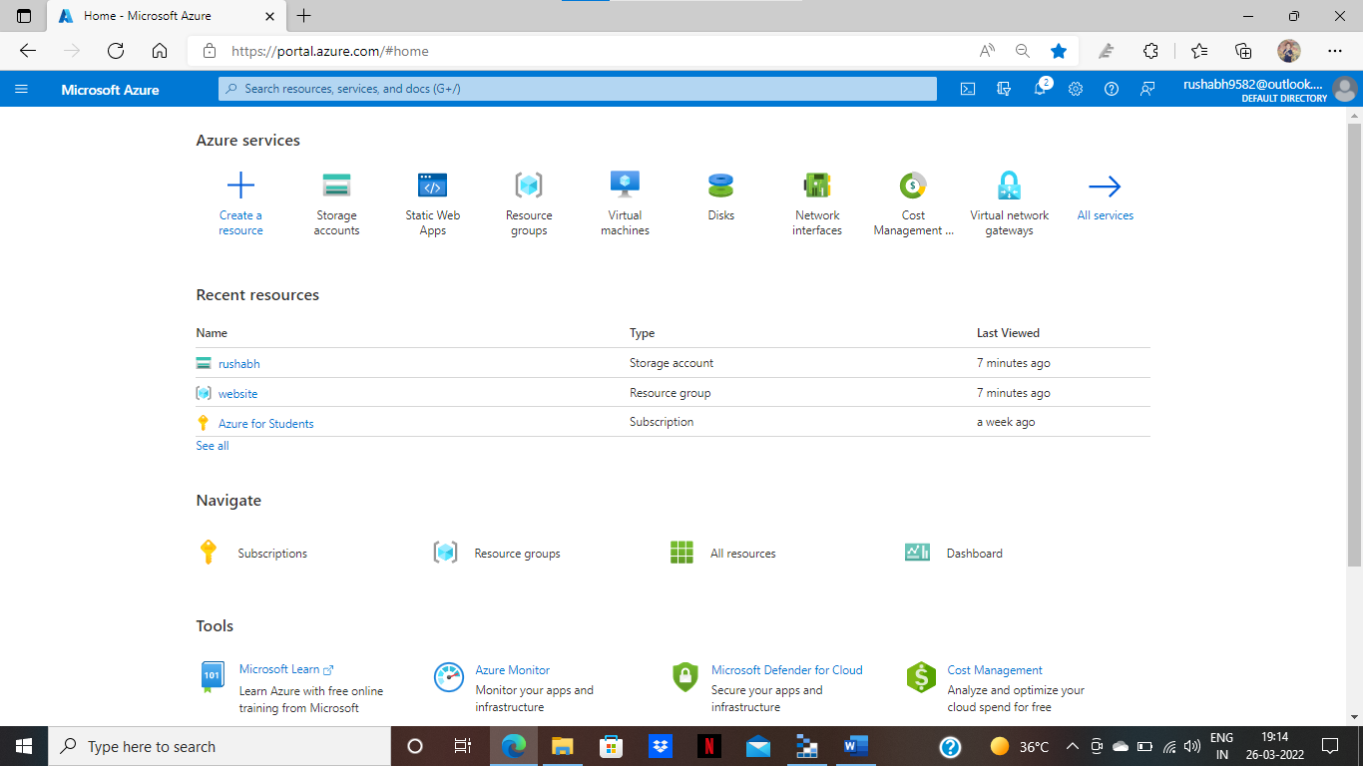

Step: -1 Go to <https://portal.azure.com/> and login your account.

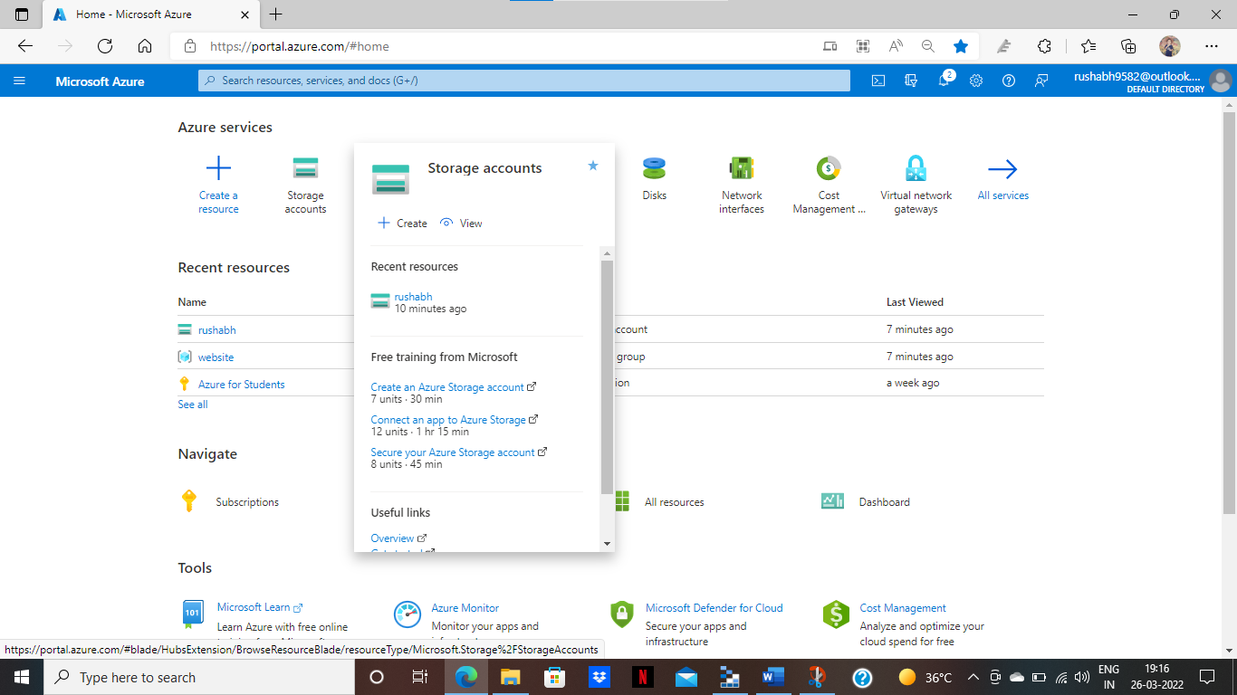

Step: -2 click to storage account and click create and assign the details.

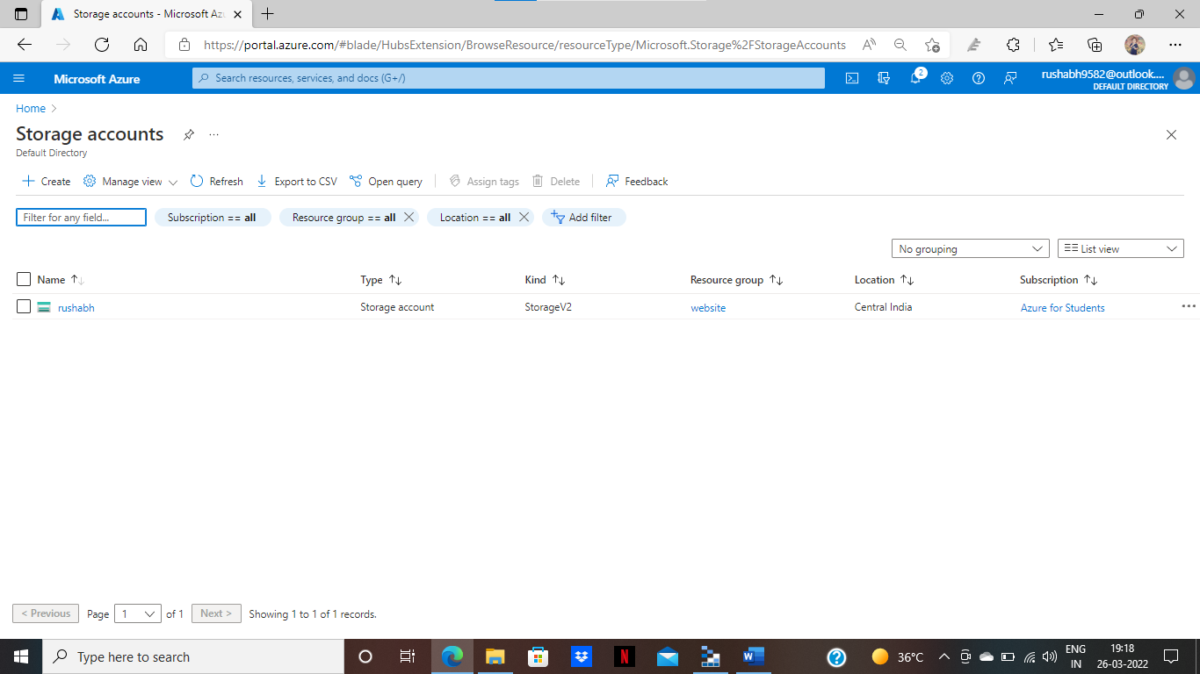

Step: -3 I have created rushabh name storage account.

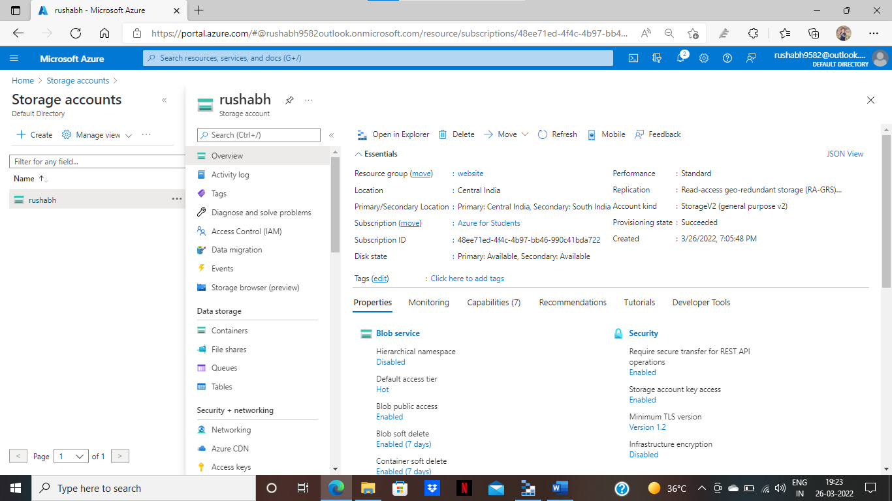

Step: -4 you can see all the details in overview page.

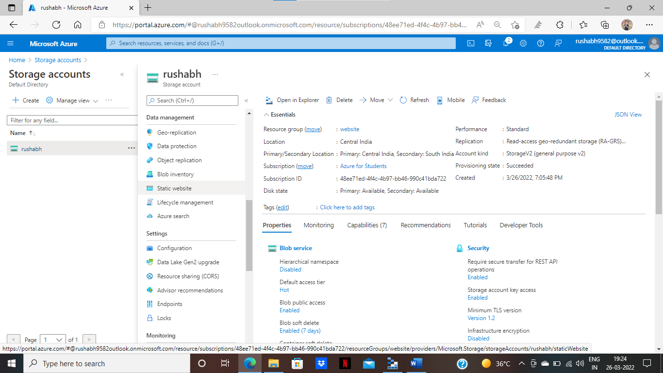

Step: -5 click to Static Website option.

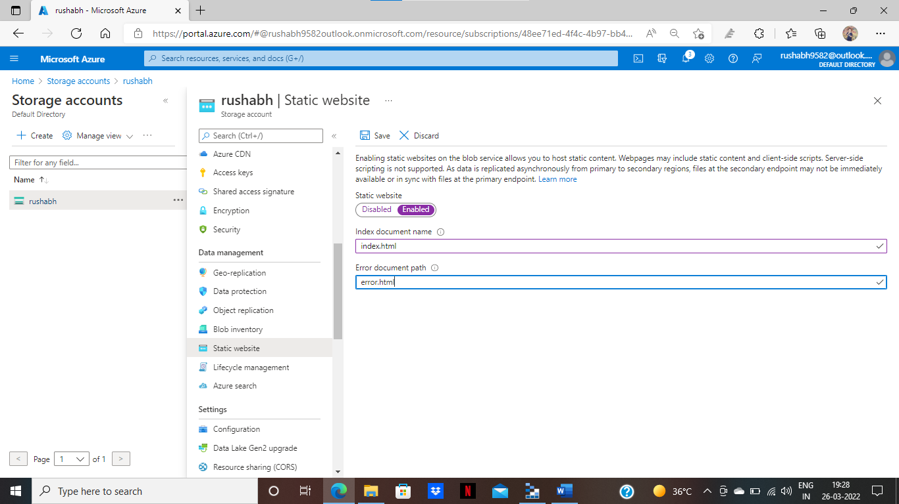

Step: -6 click to enable and assign index.html name in index document name and error.html name in error document path.

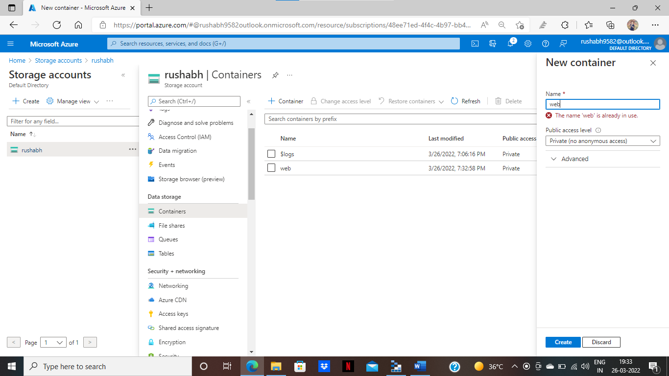

Step: -7 now go to containers and you can see web container is automatic created.

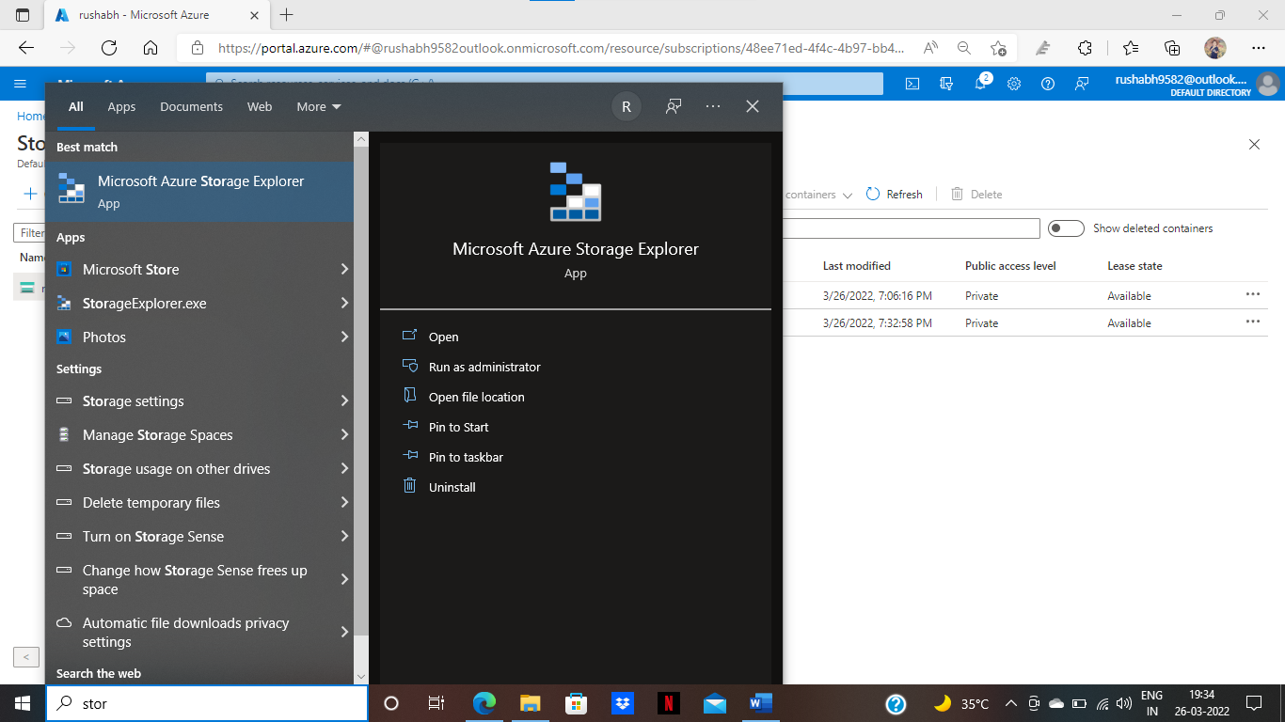

Step: -8 now go to Microsoft Azure storage explorer.

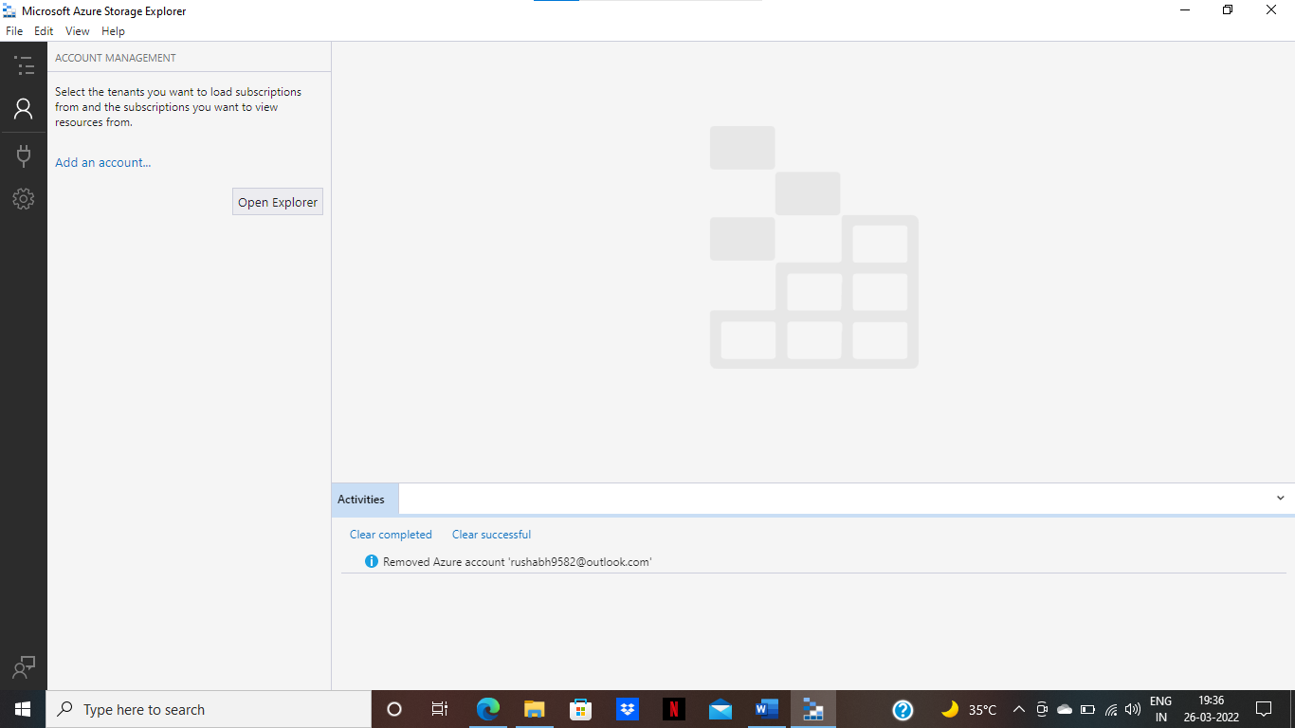

Step: -9 Go to Account Management and click to add Account.

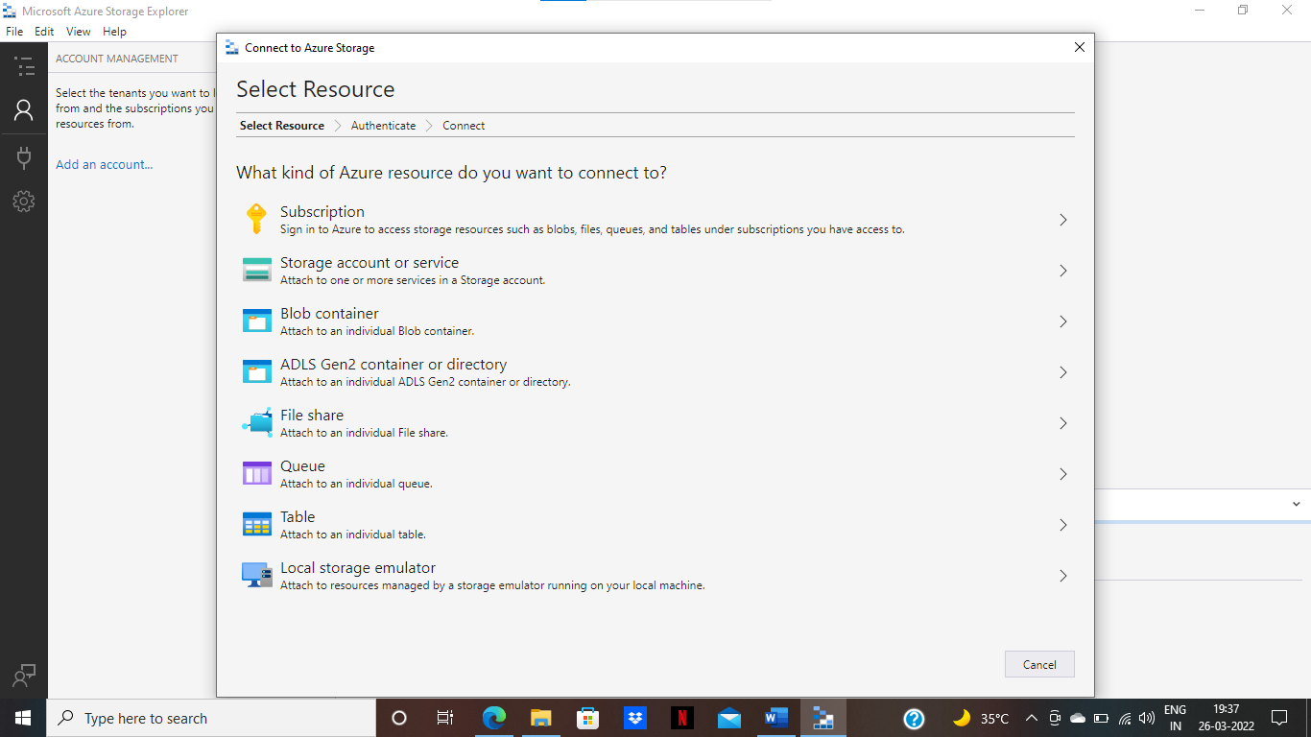

Step: -10 click to subscription option.

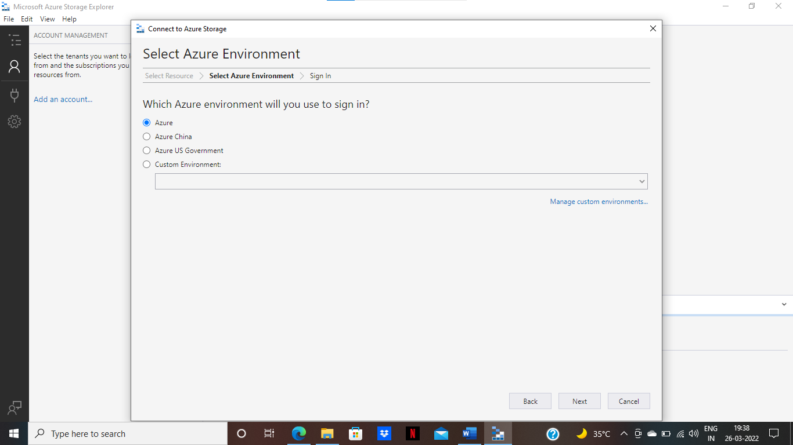

Step: -11 click to Azure and click next.

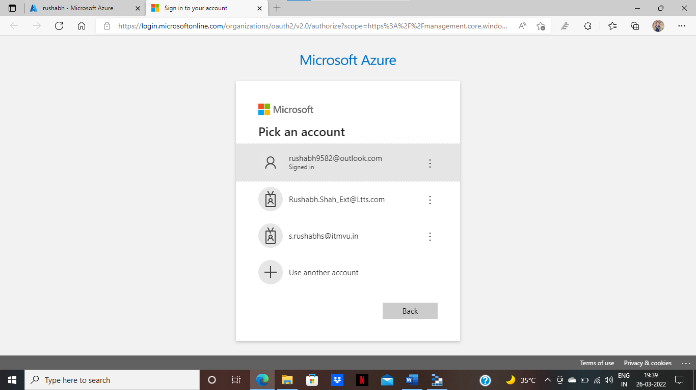

Step: -12 now Authenticate your Account.

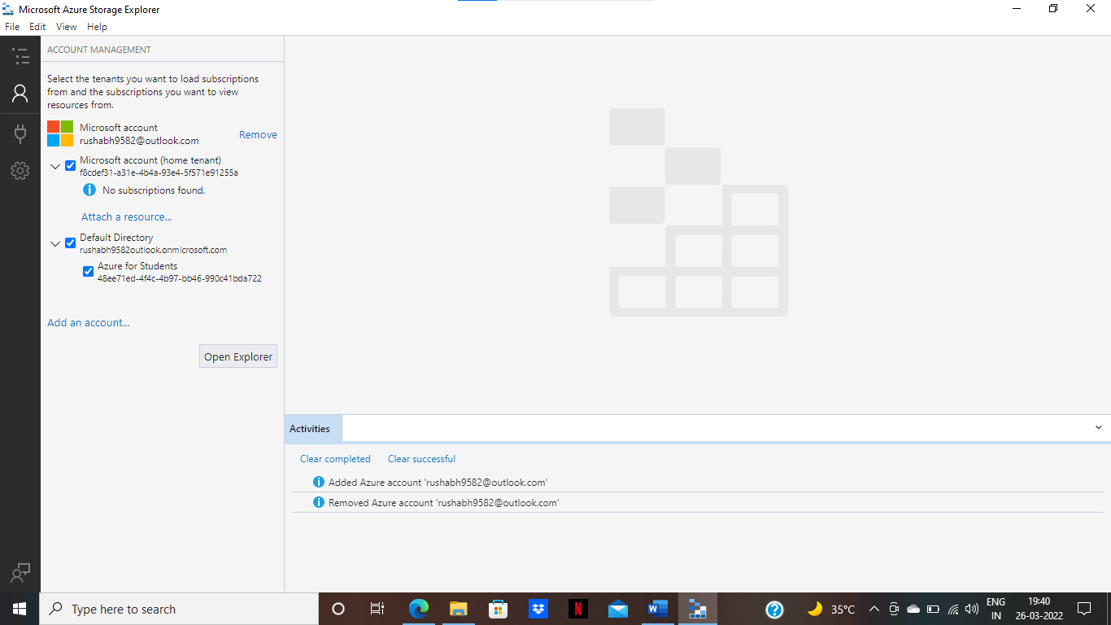

Step: -13 Now you can see Account successfully added and also added subscription.

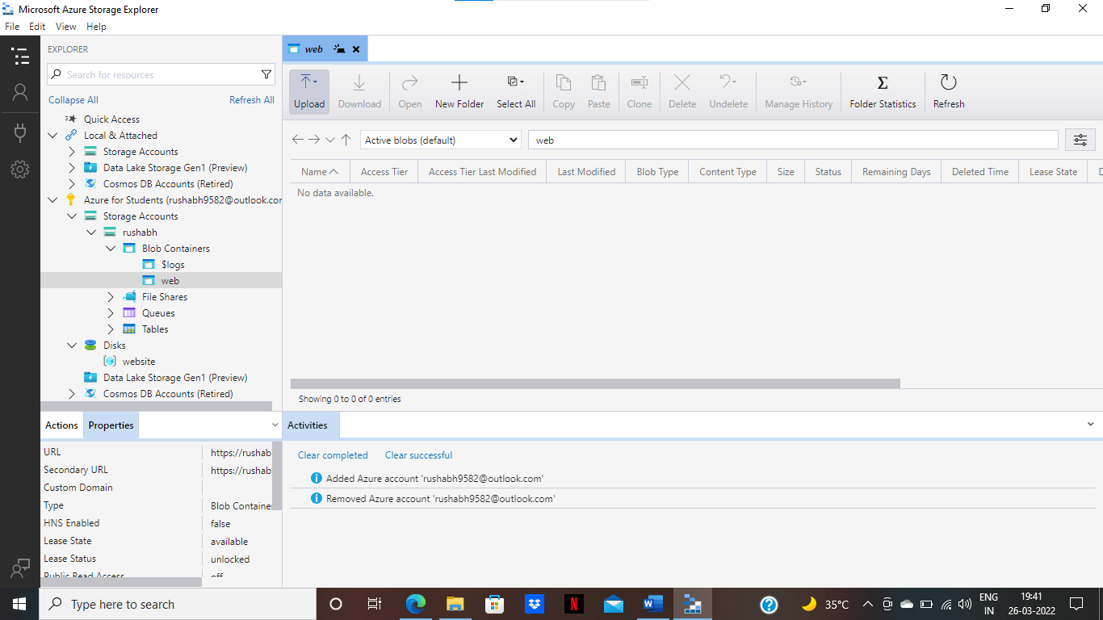

Step: -14 Go to explorer and click azure for student subscription and drop down storage account and drop down rushabh and drop down Blob Container and now you can see web container.

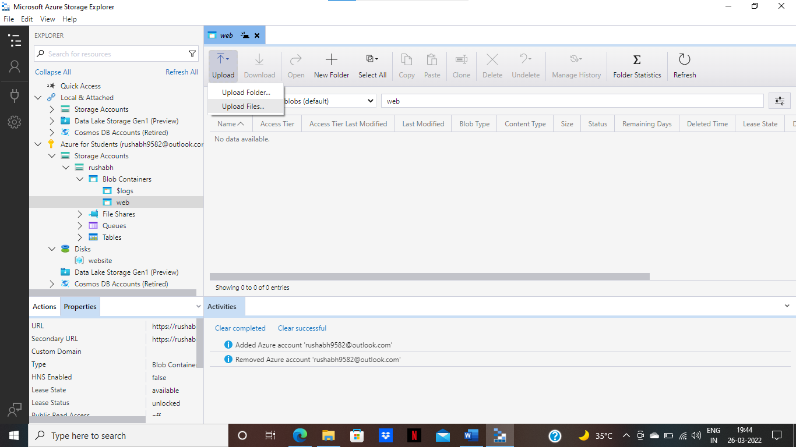

Step: -15 click to upload and click upload files.

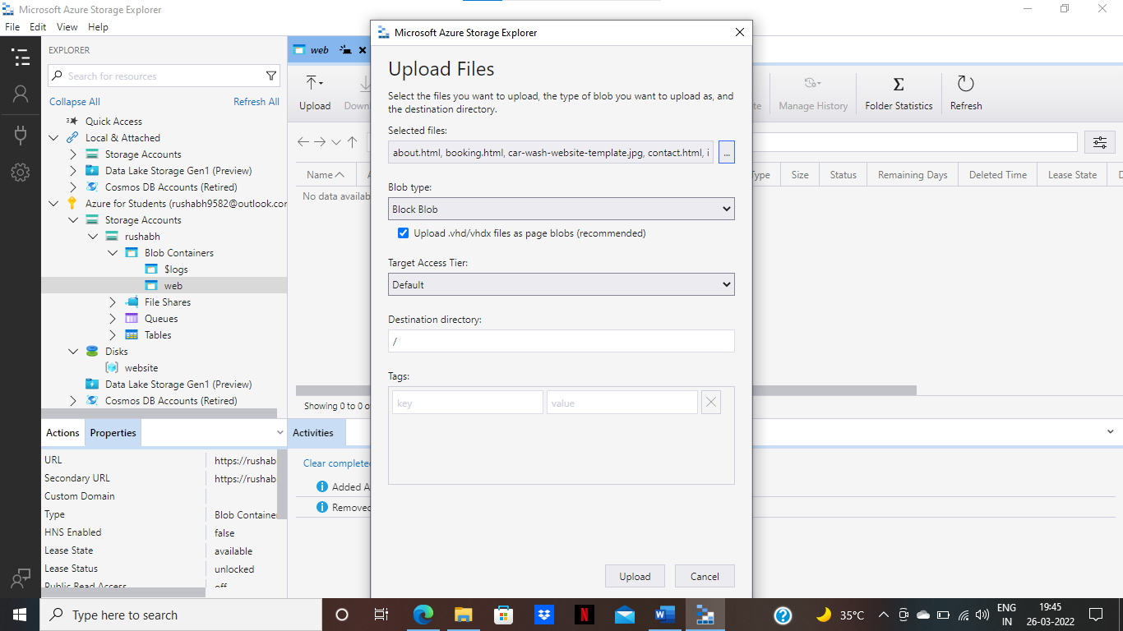

Step: -16 select file and click to upload.

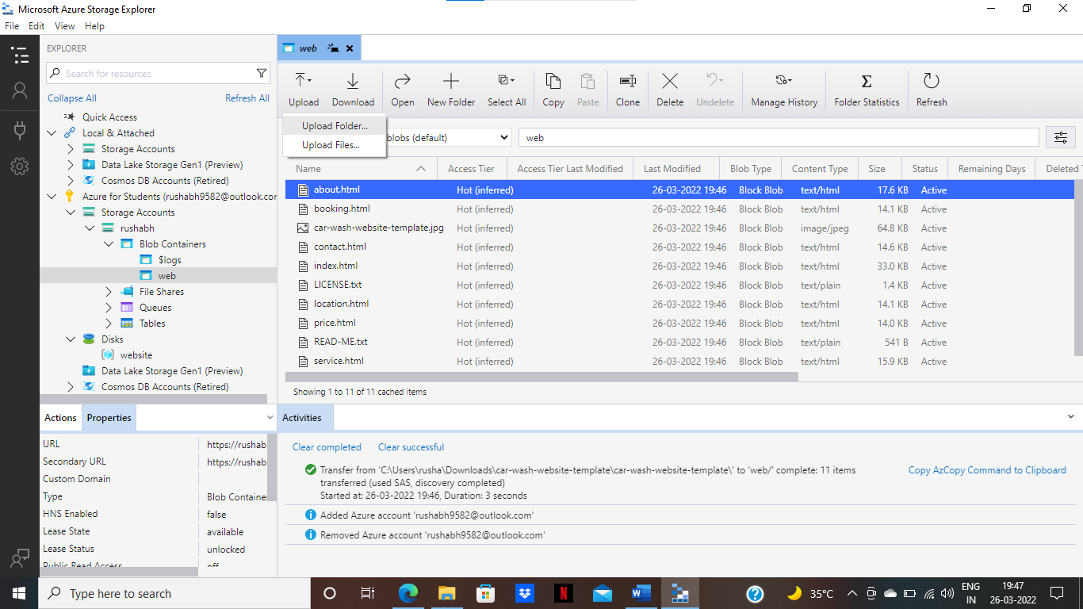

Step: -17 click to upload folder.

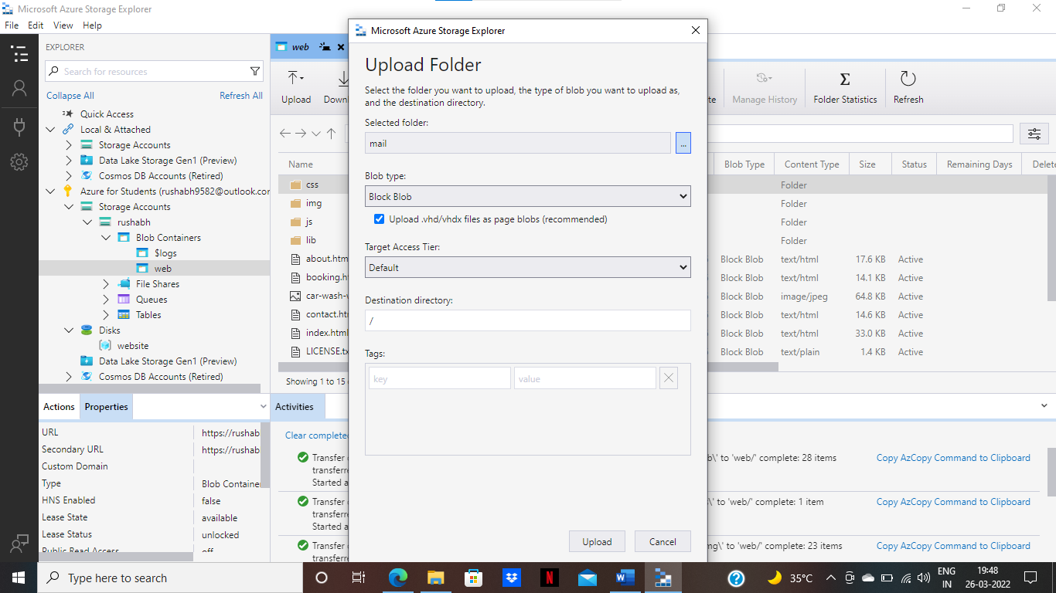

Step: -18 select folder and click to upload.

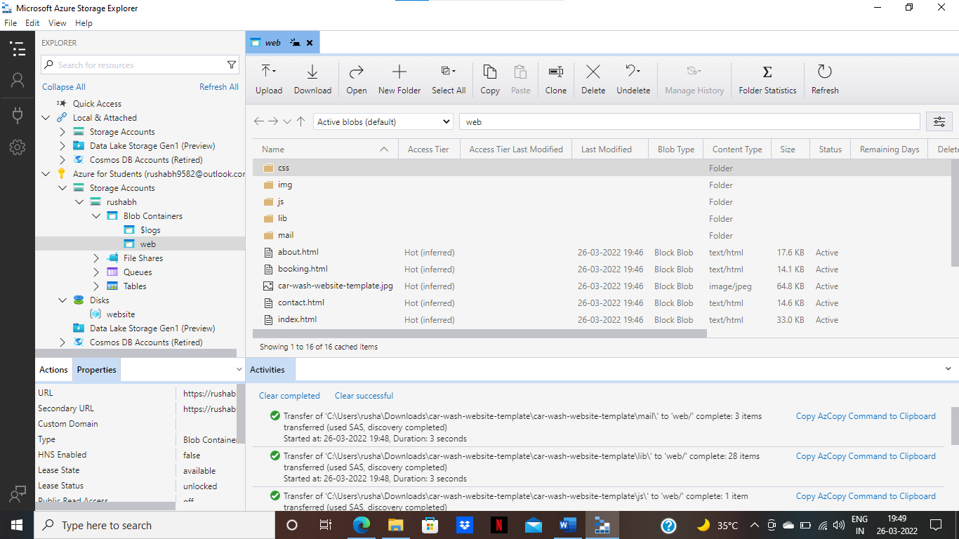

Step: -19 now you can see folder and images uploaded s successfully using Microsoft Azure Storage Explorer.

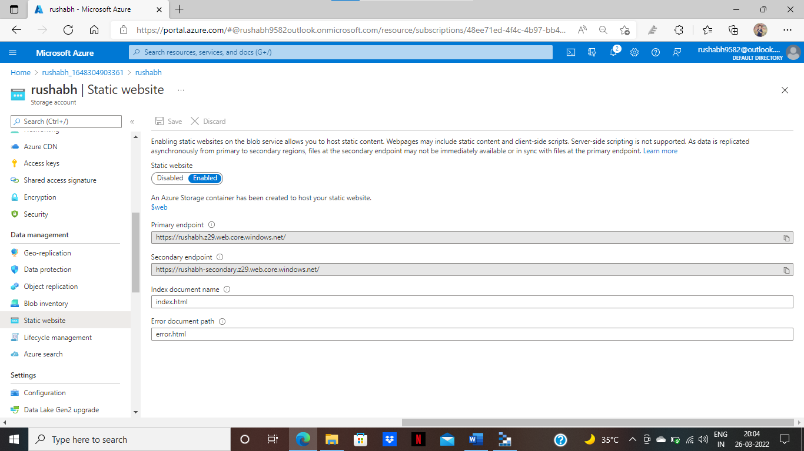

Step: -20 Go to azure portal and click to Static Website and copy primary endpoint URL and paste the New Tab.



Step: -21 now you can see output.